F

**Pamantasan ng Lungsod ng Muntinlupa**

University Road NBP Reservation, Barangay Poblacion 1770 Muntinlupa City, Philippines

Name: Reylene Grace A. Loyola. Date: October 14 2021

Course and Section: BSIT 1B Professor: Mark Jayson Aquino

Subject: Fundamentals of Programming Quiz

**Quiz**

I. Put your answer before the number.

**String**  1. Data type used to store a series of related characters.

**Data Types** 2. A set of values together with a set of allowed operations.

**Reserved words** 3. It is like kep. it consists of letters in lowercase.

**Floating-Point** 4. Data type used to store whole numbers and fractional values. **Identifier**  5. are names that appear in programs. Some of its example is variables, constants, and functions.

**Comments** 6. Always start with the symbol If. It gives brief explanation about the program

**Whitespaces** 7. Are the blanks; tabs, and newlines. It is used to separate special symbols, reserved words, and identifiers. They make programs more readable.

**Boolean** 8. Data type used to store a true or false value.

**Integer** 9. Data type used to store a number that is either positive or negative.

**DataType VariableName;**

**Data type <space> variable name and semicolon** 10. What is the syntax of declaring a variable in C-w?

**Laboratory**

Code:

#include<iostream>

using namespace std;

int main(int argc, char *argv[])

{

cout << "CCCCCCCCC \n";

cout << "CC \n";

cout << "CC \n";

cout << "CC \n";

cout << "CC \n";

cout << "CC \n";

cout << "CCCCCCCCC \n \n \n";

cout << " ++ \n";

cout << " ++ \n";

cout << "++++++++++++ \n";

cout << "++++++++++++ \n";

cout << " ++ \n";

cout << " ++ \n \n \n";

cout << " **\n";

cout << " * *\n";

cout << " * *\n";

cout << " ********\n";

cout << " * *\n";

cout << "* *";

return 0;

}

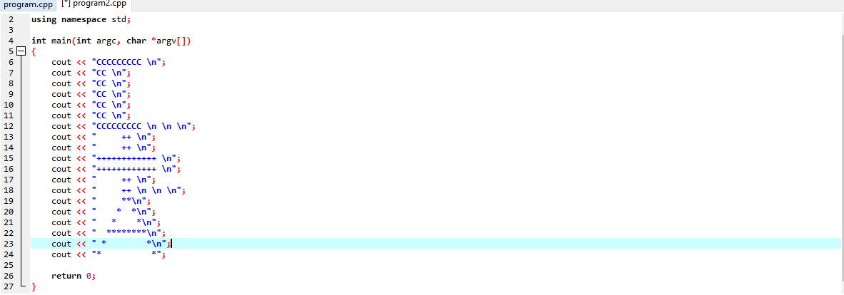

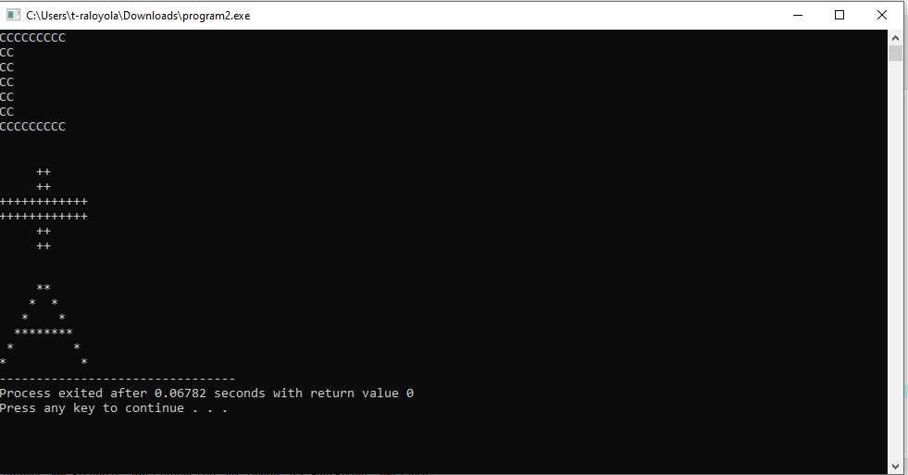

#include <iostream>

using namespace std;

int main()

{

cout << "ccccccccccc ++ *" << endl;

cout << "cc ++ * *" << endl;

cout << "cc ++ * *" << endl;

cout << "cc ++++++++++++ *******" << endl;

cout << "cc ++++++++++++ * *" << endl;

cout << "cc ++ * *" << endl;

cout << "cc ++ * *" << endl;

cout << "ccccccccccc ++ * *" << endl;

return 0;

}

